2/23/2026
LAB NO 03
Mobile Computing
Submitted by: Wasif Ali (245187)
Course: MC
Instructor: Sir Haris

Task 01:
Output:
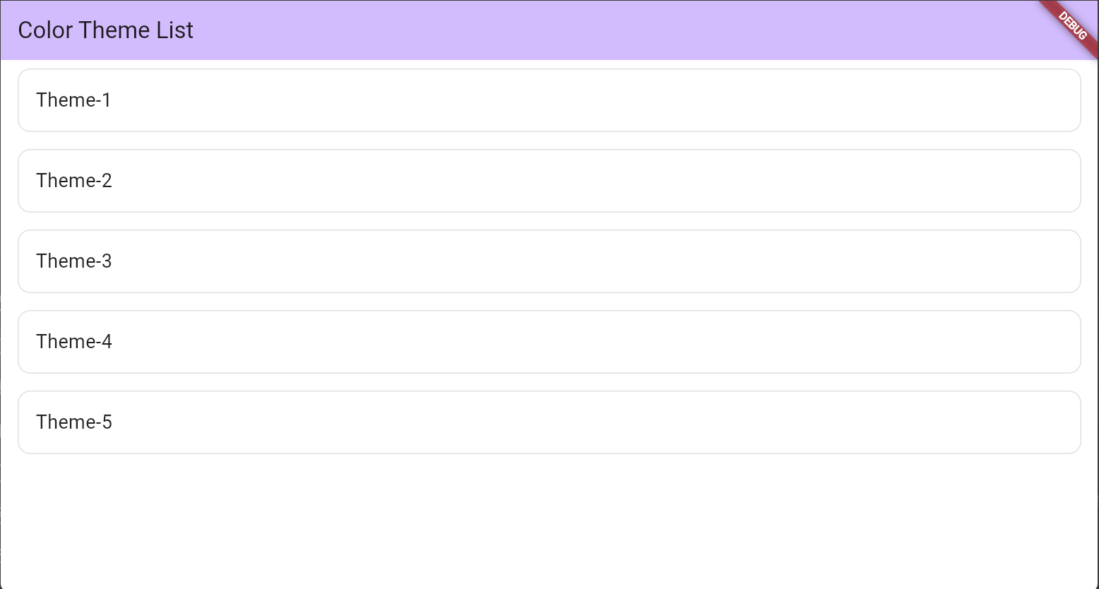
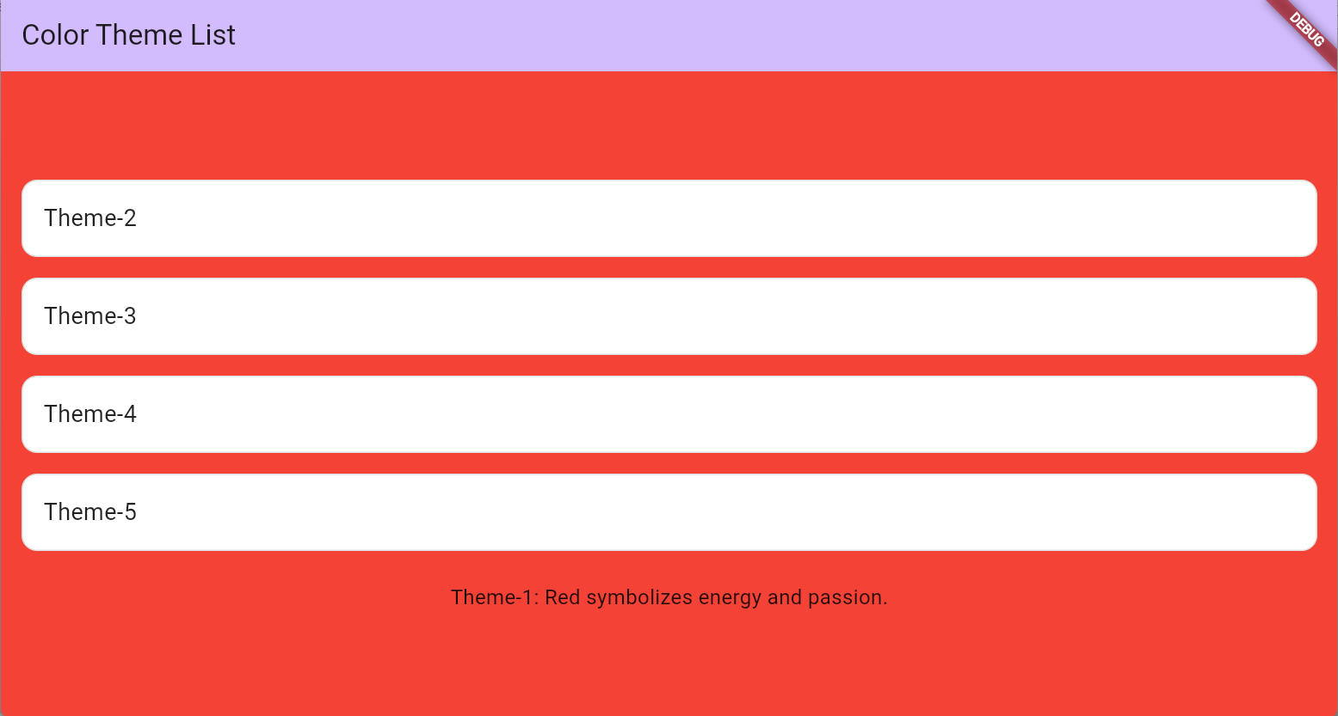
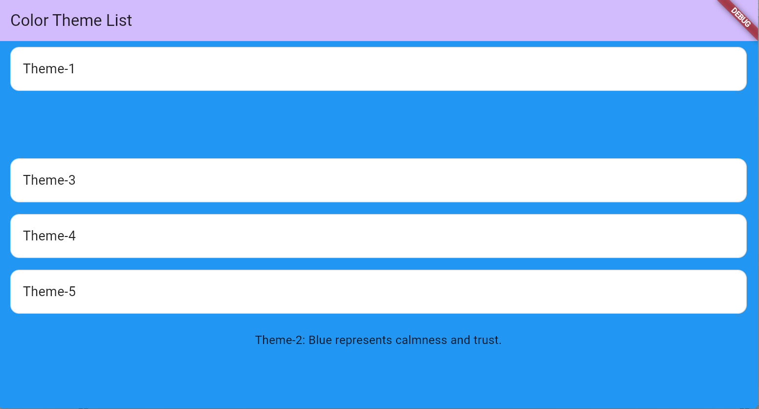
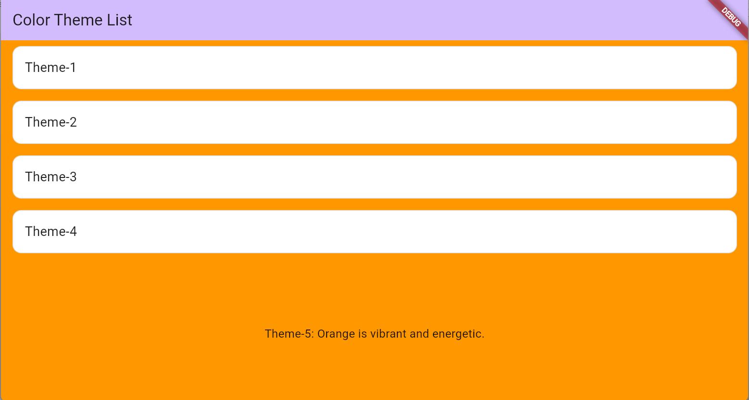
FULL CODE:
import 'package:flutter/material.dart';
void main() {
runApp(const MyApp());
}
class MyApp extends StatelessWidget {
const MyApp({super.key});
@override
Widget build(BuildContext context) {
return MaterialApp(
title: 'Color Theme List',
theme: ThemeData(
colorScheme: ColorScheme.fromSeed(seedColor: Colors.deepPurple),
),
home: const MyHomePage(title: 'Color Theme List'),
);
}
}
class MyHomePage extends StatefulWidget {
const MyHomePage({super.key, required this.title});
final String title;
@override
State<MyHomePage> createState() => _MyHomePageState();
}
class _MyHomePageState extends State<MyHomePage> {
// List of color names
List<String> colorsName = ["Theme-1", "Theme-2", "Theme-3", "Theme-4", "Theme-5"];
// List of corresponding Colors
List<Color> colors = [
Colors.red,
Colors.blue,
Colors.green,
Colors.yellow,
Colors.orange,
];
// Descriptions for each theme
List<String> descriptions = [
"Theme-1: Red symbolizes energy and passion.",
"Theme-2: Blue represents calmness and trust.",
"Theme-3: Green signifies growth and harmony.",
"Theme-4: Yellow is bright and cheerful.",
"Theme-5: Orange is vibrant and energetic.",
];
int selectedIndex = -1; // selected item
@override
Widget build(BuildContext context) {
return Scaffold(
// Background color changes with selected index
backgroundColor: selectedIndex == -1 ? Colors.white : colors[selectedIndex],
appBar: AppBar(
backgroundColor: Theme.of(context).colorScheme.inversePrimary,
title: Text(widget.title),
),
body: ListView.builder(
itemCount: colorsName.length + 1, // +1 for the description at the bottom
itemBuilder: (context, index) {
if (index < colorsName.length) {
// Theme buttons
bool isSelected = selectedIndex == index;
return GestureDetector(
onTap: () {
setState(() {
selectedIndex = index;
});
},
child: AnimatedContainer(
duration: const Duration(milliseconds: 250),
margin: const EdgeInsets.symmetric(horizontal: 16, vertical: 8),
padding: const EdgeInsets.all(16),
decoration: BoxDecoration(
color: isSelected
? colors[index].withOpacity(0.3)
: Colors.white,
borderRadius: BorderRadius.circular(12),
border: Border.all(
color: isSelected ? colors[index] : Colors.grey.shade300,
),
),
child: Text(
colorsName[index],
style: TextStyle(
fontSize: 18,
fontWeight: FontWeight.w500,
color: isSelected ? colors[index] : Colors.black87,
),
),
),
);
} else {
// Description at the bottom, centered
return AnimatedCrossFade(
firstChild: const SizedBox.shrink(),
secondChild: Padding(
padding: const EdgeInsets.all(16.0),
child: Center(
child: Text(
selectedIndex == -1 ? "" : descriptions[selectedIndex],
textAlign: TextAlign.center,
style: const TextStyle(
fontSize: 16,
color: Colors.black87,
),
),
),
),
crossFadeState: selectedIndex == -1
? CrossFadeState.showFirst
: CrossFadeState.showSecond,
duration: const Duration(milliseconds: 300),
);
}
},
),
);
}
}

Task 02:
Output:
Current Location:
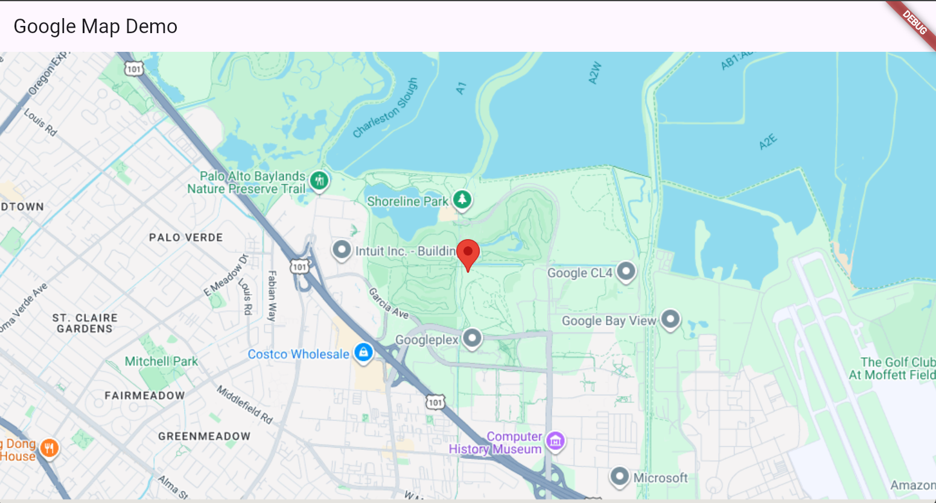
Zoom out View:
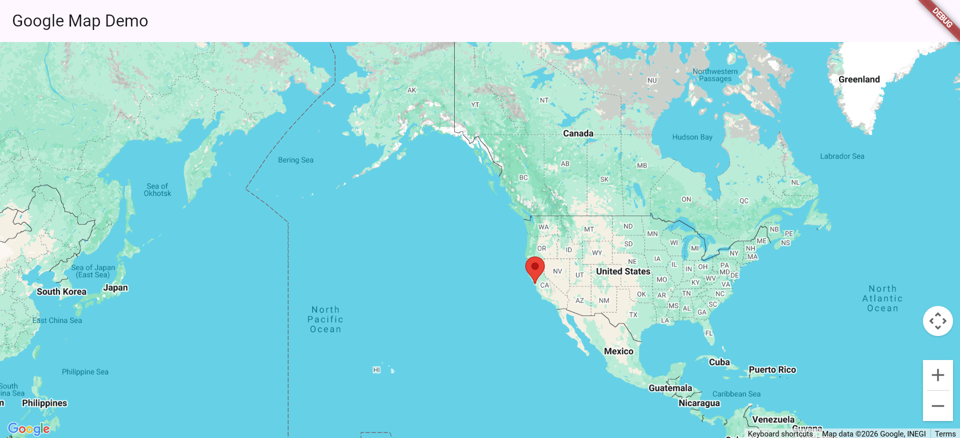

Full Code:
import 'package:flutter/material.dart';
import 'package:google_maps_flutter/google_maps_flutter.dart';
void main() {
runApp(const MyApp());
}
class MyApp extends StatelessWidget {
const MyApp({super.key});
@override
Widget build(BuildContext context) {
return MaterialApp(
title: 'Google Maps Flutter Demo',
theme: ThemeData(
colorScheme: ColorScheme.fromSeed(seedColor: Colors.deepPurple),
),
home: const MyHomePage(title: 'Google Map Demo'),
);
}
}
class MyHomePage extends StatefulWidget {
const MyHomePage({super.key, required this.title});
final String title;
@override
State<MyHomePage> createState() => _MyHomePageState();
}
class _MyHomePageState extends State<MyHomePage> {
late GoogleMapController mapController;
// Initial location of the map (Googleplex as example)
static const CameraPosition _kGooglePlex = CameraPosition(
target: LatLng(37.42796133580664, -122.085749655962),
zoom: 14.4746,
);
// Called when the map is created
void _onMapCreated(GoogleMapController controller) {
mapController = controller;
}
@override
Widget build(BuildContext context) {
return Scaffold(
appBar: AppBar(
title: Text(widget.title),
),
body: GoogleMap(
mapType: MapType.normal,
initialCameraPosition: _kGooglePlex,
onMapCreated: _onMapCreated,
markers: {
const Marker(
markerId: MarkerId('googleplex'),
position: LatLng(37.42796133580664, -122.085749655962),
infoWindow: InfoWindow(
title: 'Googleplex',
snippet: "Google's Headquarters",
),
),
},
),
);
}
}

